Numbers 1:20-46

https://thebiblesays.com/commentary/num/num-1/numbers-120-46/

Verses 20 – 46 relates the count of the number of men qualified for warfare by each tribe. The last three verses record the totals.
The material in this section of the chapter is very repetitive. The record for each tribe is two verses long. The wording used to describe the number of qualified men in each tribe is practically identical. The numbers at the end of each tribal record was the number of young men that would serve as soldiers during battle along the journey in the wilderness.
The presentation for each tribe is as follows:
–Of the sons of [tribal name]
–Their genealogical registration by their families
–By their fathers’ households
–According to the number of names
–From twenty years old and upward
–Whoever was able to go out to war
–Their numbered men of the tribe of [tribal name] were [number of men]
This created a record of available fighting men. Their location was known, based on their family connection. Each tribe camped together, so each person would be relatively easily located. The goal was to have a written record of those who were able to go out to war on behalf of Israel.
The conclusion and summary of the census is found in verses 44 – 46.
The following is a table of the numbers of men in each tribe qualified to serve in the military:

TRIBE | # OF MEN
Reuben | 46,500 (vv. 20-21)
Simeon | 59,300 (vv. 22-23)
Gad | 45,650 (vv. 24-25)
Judah | 74,600 (vv. 26-27)
Issachar | 54,400 (vv. 28-29)
Zebulun | 57,400 (vv. 30-31)
Ephraim | 40,500 (vv. 32-33)
Manasseh | 32,200 (vv. 34-35)
Benjamin | 35,400 (vv. 36-37)
Dan | 62,700 (vv. 38-39)
Asher | 41,500 (vv. 40-41)
Naphtali | 53,400 (vv. 42-43)
The order of the tribes presented here appears to align with the order of encampment given in Numbers 2 and 3. This makes sense, since part of the usefulness of the census would be the ability to locate each soldier. This would be a natural reason for the census to follow family lines, since the people camped according to their tribal affiliation. The list begins on the south, with the camps of Reuben, Simeon, and Gad. Then it proceeds to the eastern camps of Judah, Issachar, and Zebulun. Then it skips to the western camps of Ephraim, Manasseh, and Benjamin. Then finally to the north and the camps of Dan, Asher, and Naphtali. Levi is left off the list. It was not numbered, since it was exempt from military service. There are still twelve tribes numbered, since Joseph’s two sons Ephraim and Manasseh are each numbered as a tribe.
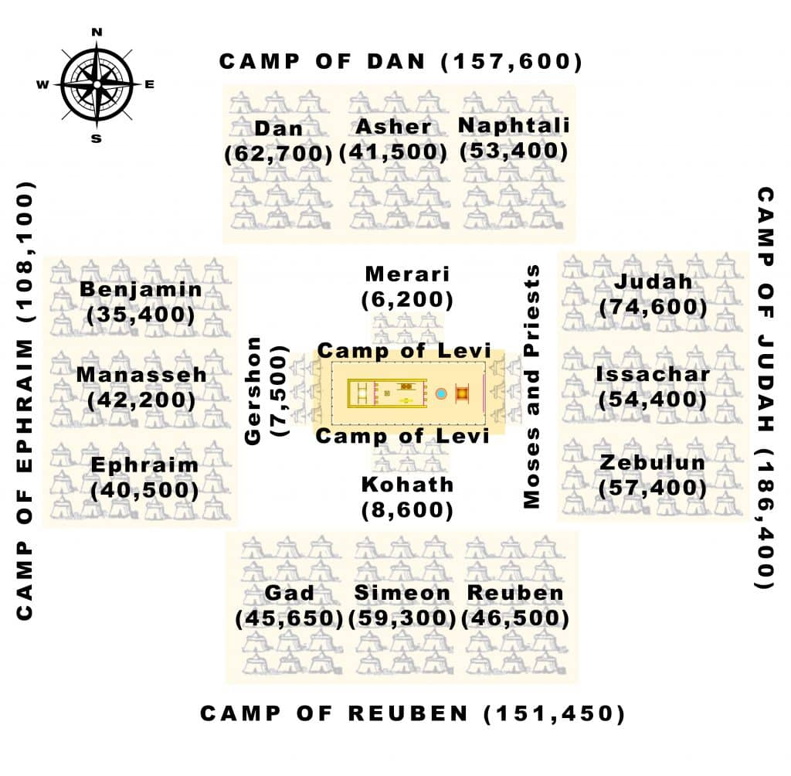
Reuben is first on the list and called Israel’s firstborn. Reuben and Simeon, the next on the list, were the two oldest sons of Jacob by his wife Leah (Genesis 29:31 – 33). Levi was the third son of Jacob, by his wife Leah, but was not listed here because the Levites were exempt from serving as soldiers in the army (Numbers 1:47 – 54). Leah had six sons in all. The other six sons of Jacob were born to different mothers, two each to Jacob’s second wife Rachel, Zilpah (Leah’s handmaid), and Bilhah (Rachel’s handmaid). The accounts of these births can be found in Genesis 29, 30, and 35. Rachel’s son Joseph had two sons that became tribes, Ephraim and Manasseh.
Verses 44 – 46 summarize the census which listed the ones who were numbered, whom Moses and Aaron numbered. This provided Israel’s leaders a full written census of available military troops, from the twelve fighting tribes, along with their location, since the families camped together with their tribes (Numbers 2-3). These fighting tribes were numbered with the leaders of Israel, twelve men. Each of the twelve tribes had a leader who would lead that tribe into battle. The phrase each of whom was of his father’s household indicates that each leader was from the tribe they led, someone the tribe would know and trust. This was done just as the LORD had commanded them.
The result was that all the numbered men of the sons of Israel by their fathers’ households, from twenty years old and upward, were able to go out to war in Israel. This indicates that able males that were twenty years old and upward were eligible for military service, other than those from the tribe of Levi. These were the men of Israel who were able to go out to war.
The total of all the numbered men were 603,550. If one added the other members of the Israelite society (women and those unfit for military duty), the total number of Israelites would likely be around two million and possibly much more. Some think this number seems too large to be feasible, and have questioned the translation or interpretation. The word translated “thousand” can also be translated as “family” or “clan” (see Judges 6:15 and 1 Samuel 10:19 for examples). Some suggest that interpretation should be applied here.
Thus, in the case of Judah, the phrase would be interpreted as 74 families plus 600 persons (the Hebrew text here is “74 eleph and 600”). If each family (or “eleph”) had 100 members, the total number of individuals in the tribe of Judah would be 7,400 plus 600 individuals in the tribe, making the total population of the tribe of Judah 8,000. This is significantly lower than the literal number of 74,600 as seen in v. 27.
Others have given different suggestions, but none of them seem to harmonize with the text. It seems best to take the word “eleph” as meaning thousand. This census is similar to the number of male Israelites just prior to departing from Egypt (Exodus 12:37). There is no reason to think the number had dwindled. The miraculous provision of the Lord for two hundred thousand does not materially differ from the miraculous provision for two million. Manna for two million can be thought of as manna for one person two million times. Either is equally miraculous. There were seventy people who left Israel to move to Egypt in Genesis 46:27. They remained in Egypt for 430 years before departing for the Promised Land (Exodus 12:40). The population growth rate required to go from seventy to two million in 430 years is about 2.4 percent per year. This is robust, but seems reasonable, since one concern voiced by Pharaoh was the excessive fertility of the Hebrews (Exodus 1:12-16).
Biblical Text
²⁰ Now the sons of Reuben, Israel’s firstborn, their genealogical registration by their families, by their fathers’ households, according to the number of names, head by head, every male from twenty years old and upward, whoever was able to go out to war,²¹ their numbered men of the tribe of Reuben were 46,500.
²² Of the sons of Simeon, their genealogical registration by their families, by their fathers’ households, their numbered men, according to the number of names, head by head, every male from twenty years old and upward, whoever was able to go out to war,²³ their numbered men of the tribe of Simeon were 59,300.
²⁴ Of the sons of Gad, their genealogical registration by their families, by their fathers’ households, according to the number of names, from twenty years old and upward, whoever was able to go out to war,²⁵ their numbered men of the tribe of Gad were 45,650.
²⁶ Of the sons of Judah, their genealogical registration by their families, by their fathers’ households, according to the number of names, from twenty years old and upward, whoever was able to go out to war,²⁷ their numbered men of the tribe of Judah were 74,600.
²⁸ Of the sons of Issachar, their genealogical registration by their families, by their fathers’ households, according to the number of names, from twenty years old and upward, whoever was able to go out to war,²⁹ their numbered men of the tribe of Issachar were 54,400.
³⁰ Of the sons of Zebulun, their genealogical registration by their families, by their fathers’ households, according to the number of names, from twenty years old and upward, whoever was able to go out to war,³¹ their numbered men of the tribe of Zebulun were 57,400.
³² Of the sons of Joseph, namely, of the sons of Ephraim, their genealogical registration by their families, by their fathers’ households, according to the number of names, from twenty years old and upward, whoever was able to go out to war,³³ their numbered men of the tribe of Ephraim were 40,500.
³⁴ Of the sons of Manasseh, their genealogical registration by their families, by their fathers’ households, according to the number of names, from twenty years old and upward, whoever was able to go out to war,³⁵ their numbered men of the tribe of Manasseh were 32,200.
³⁶ Of the sons of Benjamin, their genealogical registration by their families, by their fathers’ households, according to the number of names, from twenty years old and upward, whoever was able to go out to war,³⁷ their numbered men of the tribe of Benjamin were 35,400.
³⁸ Of the sons of Dan, their genealogical registration by their families, by their fathers’ households, according to the number of names, from twenty years old and upward, whoever was able to go out to war,³⁹ their numbered men of the tribe of Dan were 62,700.
⁴⁰ Of the sons of Asher, their genealogical registration by their families, by their fathers’ households, according to the number of names, from twenty years old and upward, whoever was able to go out to war,⁴¹ their numbered men of the tribe of Asher were 41,500.
⁴² Of the sons of Naphtali, their genealogical registration by their families, by their fathers’ households, according to the number of names, from twenty years old and upward, whoever was able to go out to war,⁴³ their numbered men of the tribe of Naphtali were 53,400.
⁴⁴ These are the ones who were numbered, whom Moses and Aaron numbered, with the leaders of Israel, twelve men, each of whom was of his father’s household.⁴⁵ So all the numbered men of the sons of Israel by their fathers’ households, from twenty years old and upward, whoever was able to go out to war in Israel,⁴⁶ even all the numbered men were 603,550.

