Numbers 1:47-54

https://thebiblesays.com/commentary/num/num-1/numbers-147-54/

Even though the Levites were one of the twelve tribes of Israel, the LORD commanded that they were not to be numbered. The reason He gave was that the Levites were designated to be the ones who maintained and transported the tabernacle, the LORD’s dwelling place amongst His people. Thus, they were to be exempt from military duty.
There has been one omission from the census. It was that the Levites, however, were not numbered among them by their fathers’ tribe. Levi was the third son of Jacob and Leah (Genesis 29:34), but the tribe of Levi did not participate in the census. There were still twelve tribes numbered, because Joseph’s two sons Ephraim and Manasseh each became a tribe.
The reason why the Levites were not included in the census was that the Lord had spoken to Moses, telling him that only the tribe of Levi you shall not number, nor shall you take their census among the sons of Israel. Thus, the LORD had set them aside for a specific task related to the tabernacle and the attendant worship of God.
The job the LORD wanted Moses to perform was to appoint the Levites over the tabernacle of the testimony, and over all its furnishings and over all that belongs to it. Here, the tabernacle is called tabernacle of the testimony. The “testimony” is a reference to the tablets containing the Ten Commandments that were placed in the ark (Exodus 31:18; 40:20).
Specifically, the LORD assigned them to carry the tabernacle and all its furnishings, and they shall take care of it. Their task was to carry all of the parts of the tabernacle and all of the furnishings, utensils, and other items associated with the tabernacle. They were also to “take care” (that is, “minister” or “serve”) the tabernacle and its furnishings.
Not only that, the LORD directed that they shall also camp around the tabernacle. This was to insulate the tabernacle from being approached or touched by those not authorized to do so. The twelve fighting tribes were to camp three by three, encircling the tabernacle, and the Levites were to camp between the fighting tribes and the tabernacle, as a buffer between the fighting tribes and the tabernacle.
This buffer was for the protection of the fighting tribes. As seen in verse 51, the consequence for a non-Levite getting near to the tabernacle could be fatal.
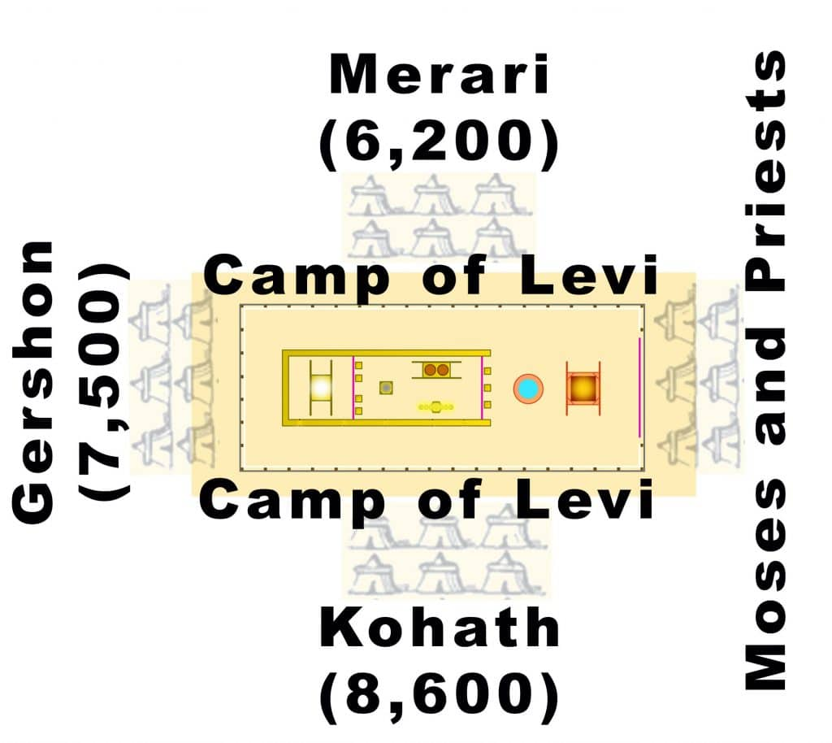

The LORD then specified the details about the service of the Levites.
–When the tabernacle is to set out, the Levites shall take it down (v. 51). The tabernacle was constructed to be portable, per the specific instructions God gave in Exodus chapters 25-31. The tabernacle was apparently constructed and erected by skilled craftsmen and the people (Exodus 36-40). But now, since the glory of the Lord descended on the tabernacle, only the Levites are allowed to interact with the tabernacle. The Levites are to take down the portable elements when they are preparing to move locations.
–When the tabernacle encamps, the Levites shall set it up.
–But the layman who comes near shall be put to death. The layman (Heb. “zar,” “stranger”) refers to a non-Levite in this context.
–In addition to dismantling and packing up the portable elements of the tabernacle, the Levites are to reassemble its parts when they reach their new destination.
–The sons of Israel shall camp, each man by his own camp, and each man by his own standard, according to their armies. The arrangement of the other tribes will be given to Moses in Numbers 2. The members of each tribe were to camp with their household, then their tribal “standard” (or “banner”).
–But the Levites shall camp around the tabernacle of the testimony, so that there will be no wrath on the congregation of the sons of Israel(v. 53). Because the Levites did not participate in military actions, they were not placed on the perimeter like the other tribes. Their position surrounding the tabernacle both symbolized their dedication to serving the tabernacle and being a buffer between it and the other tribes. Only the Levites could come near or touch the tabernacle (v. 51).
In summary, the LORD stated that the Levites shall keep charge of the tabernacle of the testimony. They were given the task of taking down and setting up the tabernacle when relocating, carrying the tabernacle through the wilderness when they were on the move, and camping around it, providing a buffer between the tabernacle and the twelve fighting tribes when they stopped.
All of this work organizing the Israelite camp the sons of Israel did. They did the work according to all which the Lord had commanded Moses, so they did (v. 54). It is interesting that the Israelites were very obedient to the LORD in regard to being organized. They were significantly less obedient when it came to worshipping Him and Him alone.
It is clear from this chapter that the LORD does not want His covenant people to operate as a disorganized group of nomads. He desires them to be well organized, and well ordered. Since He is the God of order (1 Corinthians 14:33, 40), they should be orderly.
Biblical Text
⁴⁷ The Levites, however, were not numbered among them by their fathers’ tribe.⁴⁸ For the Lord had spoken to Moses, saying,⁴⁹ “Only the tribe of Levi you shall not number, nor shall you take their census among the sons of Israel.⁵⁰ But you shall appoint the Levites over the tabernacle of the testimony, and over all its furnishings and over all that belongs to it. They shall carry the tabernacle and all its furnishings, and they shall take care of it; they shall also camp around the tabernacle.⁵¹ So when the tabernacle is to set out, the Levites shall take it down; and when the tabernacle encamps, the Levites shall set it up. But the layman who comes near shall be put to death.⁵² The sons of Israel shall camp, each man by his own camp, and each man by his own standard, according to their armies.⁵³ But the Levites shall camp around the tabernacle of the testimony, so that there will be no wrath on the congregation of the sons of Israel. So the Levites shall keep charge of the tabernacle of the testimony.”⁵⁴ Thus the sons of Israel did; according to all which the Lord had commanded Moses, so they did

