Numbers 2:1-2

https://thebiblesays.com/commentary/num/num-2/numbers-21-2/

The Lord tells Moses and Aaron to divide the Israelites into groups around the Tabernacle.
Again, the Lord spoke to Moses and to Aaron. The phrase the Lord spoke to Moses occurs in every chapter of Numbers except chapters 22 – 24, the story about Balaam. This repetition emphasizes that the fact that the LORD was the source of these commands and not something Moses dreamed up.
On this occasion, the LORD commanded that the sons of Israel shall camp. God here is organizing the formation for the sons of Israel when they stopped traveling and set up camp in the wilderness. They were to camp each by his own standard, with the banners of their fathers’ households; they shall camp around the tent of meeting at a distance. As can be seen later in this chapter, the Israelites were to arrange themselves into a square on four sides, each side having three tribes each. Each group of three would be placed on one of the sides of the tabernacle. The tribe of Levi was to be divided according to its families and placed immediately around the tabernacle, thus providing a buffer between the other tribes and the tabernacle.
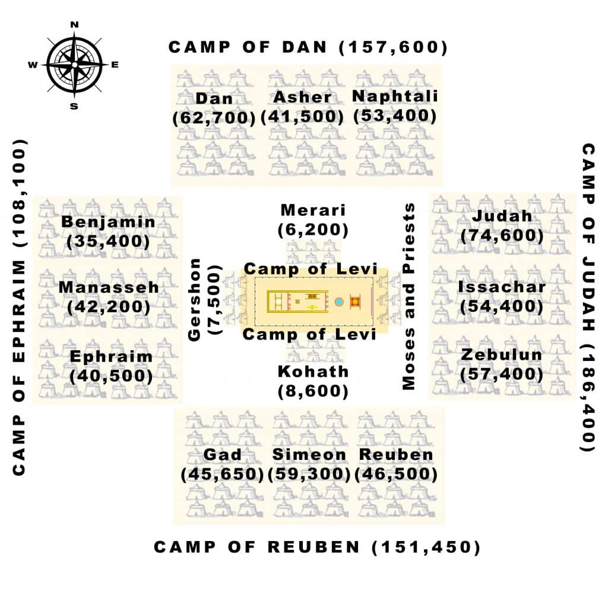
The order of the phrases as seen in the Hebrew text of v. 2 reads as follows:
Each by his own standard,
With the banners of their fathers’ households,
The sons of Israel shall camp,
Around the tent of meeting at a distance,
They shall camp.
The first phrase each by his own standard stresses that this command was directed to each and every Israelite. Each one was to gather by his own standard. A standard (Hebrew “degel”) was a banner that identified a group. It appears that each individual family was to gather with their own standard around their “father’s households,” which were identified by “banners” (Heb. “otot”). Each family of each tribe was to congregate together, and apparently were to clearly identify themselves. This organization and identification would presumably reflect the census. This organization appears to be a typical military structure.
The tribes were to camp around the tent of meeting. The tribes were to surround the tabernacle, completely encompassing it. This would provide a strong defense perimeter. They were also to camp at a distance from the tabernacle. A holy God (who dwelled in the “tent of meeting”) could not be approached by someone who was not a priest and who was not clean. For the LORD to command them to camp at a distance showed His grace by warning them not to come near to Him, as well as His holiness, since coming too close might have deadly results.
Biblical Text
¹ Now the Lord spoke to Moses and to Aaron, saying,² “The sons of Israel shall camp, each by his own standard, with the banners of their fathers’ households; they shall camp around the tent of meeting at a distance.

