Numbers 2:25-31

https://thebiblesays.com/commentary/num/num-2/numbers-225-31/

The three tribes assigned to the north side of the tabernacle were Dan, Asher, and Naphtali. The number of men eligible for military service was given for each tribe. Also their leaders were named. These tribes were to move out last when the Israelites made their way through the wilderness.
The three tribes on the north were to gather around the standard of the camp of Dan. Thus the three tribes on the northern side were to bear the name “camp of Dan.” Dan was the first son of Rachel’s maid (Genesis 30:1 – 5).
Like the others, these tribes on the north were arranged by their armies. Each tribe was an army in and of itself. The leader of the sons of Dan was then named. It was Ahiezer the son of Ammishaddai. This agrees with what was stated in Numbers 1:12. The size of his army, even their numbered men, was 62,700. This is the same number that was given in Numbers 1:39.
The second tribe to camp on the north and to camp next to him [i.e., Dan] shall be the tribe of Asher. Asher was the second son of Zilpah, the maid of Leah (Genesis 30:12 – 13). The leader of the sons of Asher was Pagiel the son of Ochran (Numbers 1:13). The size his army—even their numbered men, was 41,500. This is the same number that was given in Numbers 1:41.
Next in line on the northern side of the tabernacle was the tribe of Naphtali (v. 29). Naphtali was the second son of Bilhah, Rachel’s maidservant (Genesis 30:7 – 8). The leader of the sons of Naphtali was Ahira the son of Enan (Numbers 1:15). The size of Naphtali’s army, even his numbered men was 53,400. This is the same number that was given in Numbers 1:43.
So, the total of the numbered men of the camp of Dan was 157,600, by their armies. This was the total number of troops on the north side of the tabernacle. These three tribes on the north side of the camp were to set out last by their standards. When Israel went on the march, the camp of Dan would bring up the rear. The 157,600 troop strength of the camp of Dan, bringing up the rear, compared to the camp of Ephraim’s 108,100, the camp of Reuben’s 151,450, and the camp of Judah’s 186,400. The camp of Levi, who walked in the center surrounding the tabernacle, was not numbered because they were exempt from fighting.
The following list shows the complete order in which the tribes moved out when the Israelites were ordered to depart from where they were camped:
–Judah
–Issachar
–Zebulun
–Reuben
–Simeon
–Gad
–Tent of Meeting with Levites
–Ephraim
–Manasseh
–Benjamin
–Dan
–Asher
–Naphtali
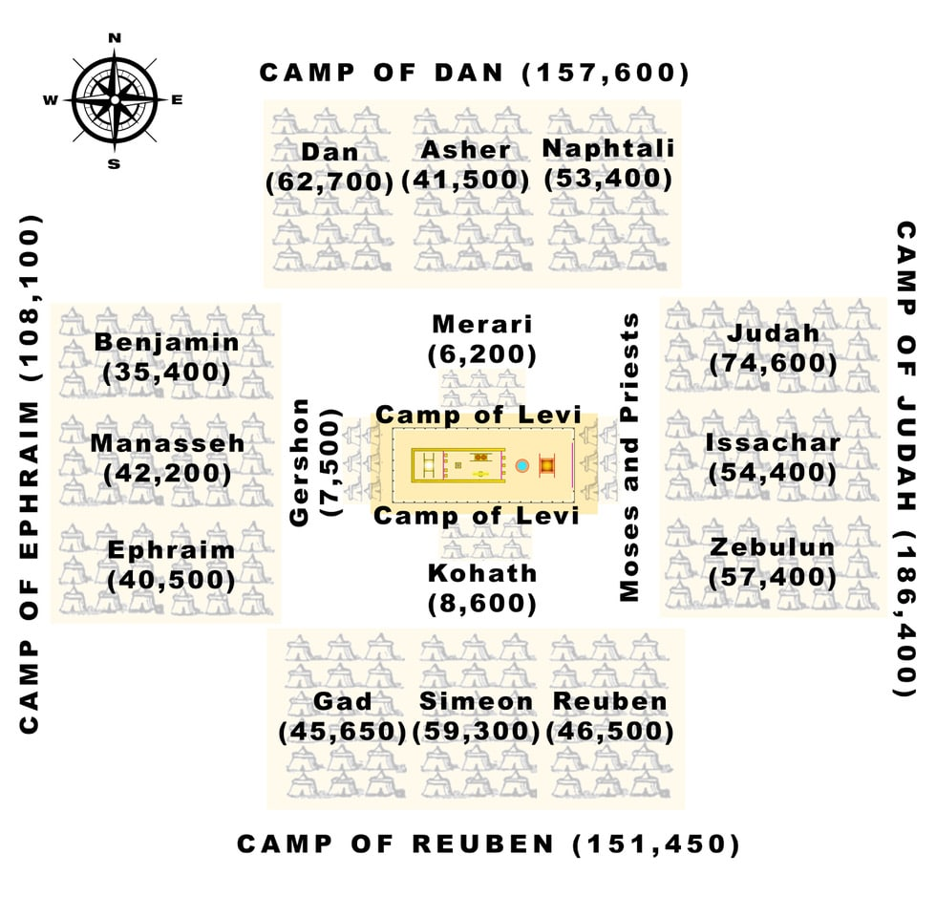
Biblical Text
²⁵ “On the north side shall be the standard of the camp of Dan by their armies, and the leader of the sons of Dan: Ahiezer the son of Ammishaddai,²⁶ and his army, even their numbered men, 62,700.²⁷ Those who camp next to him shall be the tribe of Asher, and the leader of the sons of Asher: Pagiel the son of Ochran,²⁸ and his army, even their numbered men, 41,500.²⁹ Then comes the tribe of Naphtali, and the leader of the sons of Naphtali: Ahira the son of Enan,³⁰ and his army, even their numbered men, 53,400.³¹ The total of the numbered men of the camp of Dan was 157,600. They shall set out last by their standards.”

