Numbers 2:32-34

https://thebiblesays.com/commentary/num/num-2/numbers-232-34/

The grand total of the number of available troops excluding the Levites is recorded here, and it is reported that the Israelites obeyed the commands of the LORD.
Verse 32 states the total troop strength, the total number of the numbered men of the sons of Israel by their fathers’ households. In other words, the total of the numbered men, those of fighting age, twenty and older, of the camps by their armies was 603,550. This number corresponds to the one given in Numbers 1:46.
As can be seen in this chapter, the Levites, however, were not numbered among the sons of Israel. This was donejust as the Lord had commanded Moses (Numbers 1:57). The Levites were to be dedicated to tabernacle and worship service, and were exempted from military service.
Verse 34 states that Israel obeyed God’s command in this matter, and organized themselves according to God’s instructions, stating plainly: thus the sons of Israel did. That is, they did according to all that the Lord commanded Moses. This means that they camped by their standards, and so they set out, every one by his family according to his father’s household. Thus, the people of Israel were in total compliance with what the LORD commanded them concerning the arrangement of the tribes when camped and the order in which the tribes were to make their way to the Promised Land. They camped in the order prescribed, and they marched in the order prescribed.
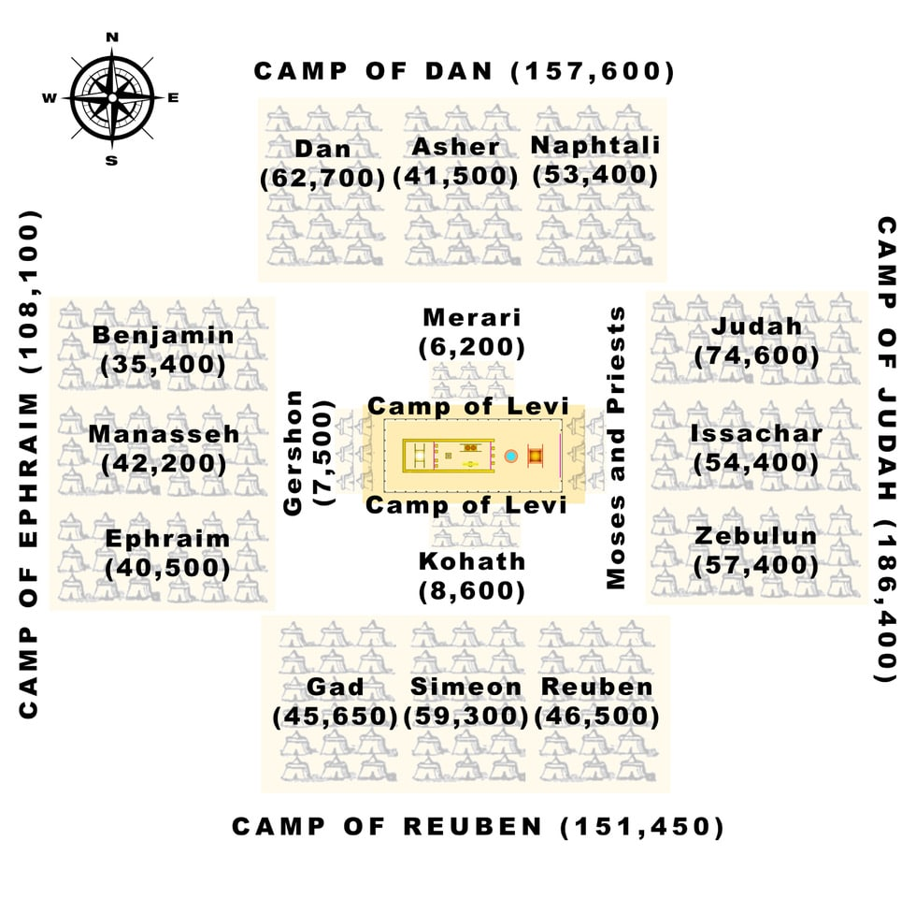
Some have speculated that the Israelite camp, comprised of around two million people, could have been around 12 miles square.
It appears that the LORD organized the tribes in this order based on their ancestry. The following table shows this:
Placement | Tribes | Ancestry
East | Judah, Issachar, and Zebulun | Descended from Leah
South | Reuben, Simeon, and Gad | Descended from Leah and her maid Zilpah
West | Ephraim, Manasseh, and Benjamin | Descended from Rachel
North | Dan, Asher, and Naphtali | Descended from the maids Bilhah and Zilpah
Biblical Text
³² These are the numbered men of the sons of Israel by their fathers’ households; the total of the numbered men of the camps by their armies, 603,550.³³ The Levites, however, were not numbered among the sons of Israel, just as the Lord had commanded Moses.³⁴ Thus the sons of Israel did; according to all that the Lord commanded Moses, so they camped by their standards, and so they set out, every one by his family according to his father’s household.

