Numbers 3:33-37

https://thebiblesays.com/commentary/num/num-3/numbers-333-37/

Verses 33 through 37 describe the next group to be considered. It was the family of Merari, the third born son of Levi. As in the previous sections, it recorded their numbers, their placement in the camp, and their duties in service to the priests and the tabernacle.
The two families of Merari were:
–The family of the Mahlites. Mahli was the firstborn son of Levi.
–The family of the Mushites. Mushi was the second born son of Levi.
So, these were the families of Merari (“strong”).
The total of the family of Merari’s numbered men in the numbering of every male from a month old and upward, were 6,200. This census compares to the total number number of fighting men of the camp of Dan totaling 157,600.
Verse 35 records the leader of the fathers’ households of the families of Merari. It was Zuriel the son of Abihail. Zuriel means “God is my rock”, and Abihail means “My Father [God] is mighty.” There is no mention whether Zuriel was descended from Mahli or Mushi. The LORD commanded that the families camp on the northward side of the tabernacle. This would place the Levites who were sons of Merari as a buffer between the tabernacle and the camp of Dan on the north side of the camp.
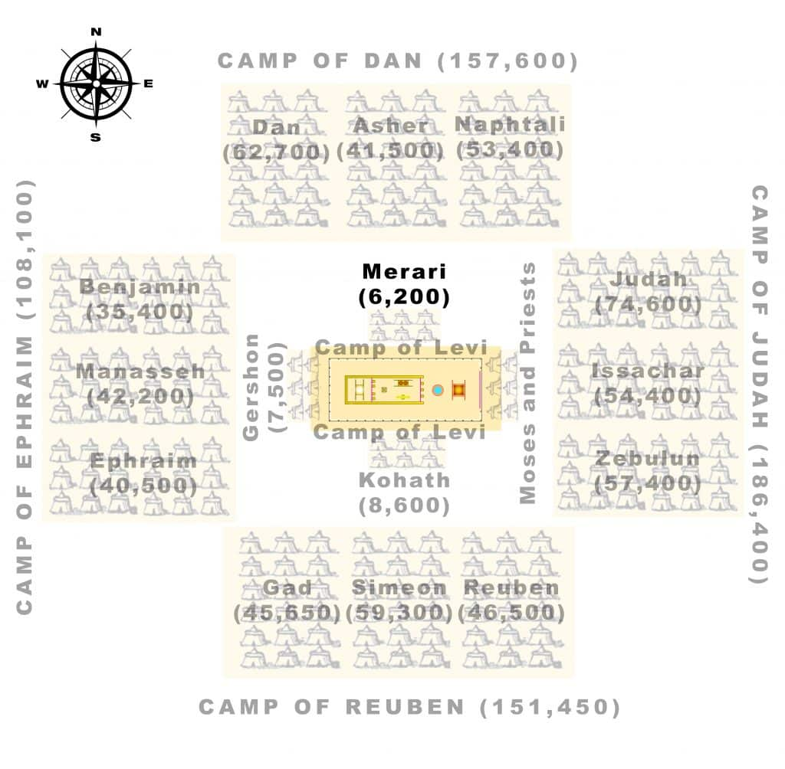
Included in the appointed duties of the sons of Merari were:
–The frames of the tabernacle. This would be the frame over which the drapes were laid, in order to create the tent that was the sanctuary, or tent of meeting.
–Its bars. These were probably crossbars that supported the sides and trellises of the tabernacle
–Its pillars, which would have been the tent poles.
–Its sockets, which would connect the pillars and crossbars.
–All its equipment. This word is also translated “utensils” and likely refers to the pails for removing its ashes, and its shovels and its basins and its forks and its firepans (Exodus 27:3).
–The service concerning them. Anything related to care and transport would be the duty of the sons of Merari. However, they would not be allowed to minister inside the tabernacle, as that duty was reserved to the sons of Aaron, who were assigned as priests.
–The pillars around the court with their sockets and their pegs and their cords. This refers to the pillars (tent poles), pegs (tent stakes), and cords (that connected the pillars to the pegs) that was erected upon which the drapes were hung for the outer court that surrounded the tabernacle.
The families of Merari were tasked with keeping the items that made up the structure of the tabernacle. The pieces of wood that comprised its framework, its rings, and all of the other components were to be in the “service” of the family of Merari.
Biblical Text
³³ Of Merari was the family of the Mahlites and the family of the Mushites; these were the families of Merari. ³⁴ Their numbered men in the numbering of every male from a month old and upward, were 6,200. ³⁵ The leader of the fathers’ households of the families of Merari was Zuriel the son of Abihail. They were to camp on the northward side of the tabernacle. ³⁶ Now the appointed duties of the sons of Merari involved the frames of the tabernacle, its bars, its pillars, its sockets, all its equipment, and the service concerning them, ³⁷ and the pillars around the court with their sockets and their pegs and their cords.

