Numbers 3:38-39

https://thebiblesays.com/commentary/num/num-3/numbers-338-39/

Moses and Aaron and his sons are to camp on the east side of the tabernacle. This is symbolic of Christ to come.
The last group to be located in the camp was those who were to camp before the tabernacle eastward, before the tent of meeting toward the sunrise. This was where Moses and Aaron and his sons were to camp. Since the entrance to the tabernacle was on the east side, this was a place of honor. This would place the family of Moses and Aaron as a buffer between the tabernacle and the camp of Judah. There is no mention of a number for the sons of Moses and Aaron, perhaps because they are numbered with the sons of Kohath, from whom they descended.
This was all symbolic of Christ who would come some 1500 years in the future. Judah became the lineage of King David, who became the lineage of the Messiah. The camp of Judah was situated on the east. Jesus was the fulfillment of the prophecy that a son of the house of David would sit on the throne of Israel forever (2 Samuel 7:13). Jesus is that son. Jesus is also the second Moses, fulfilling Moses’ prophecy that God would raise up someone from among Israel that was like Moses, but who would speak the word of God directly to the people (Deuteronomy 18:18). Jesus is also the entrance into the presence of God. Once inside the tabernacle, He is the veil that provides the way into the Holy of Holies. (Hebrews 10:19-20).
The presence of the camp of Judah, Aaron, and Moses on the eastern side, by the door of the tabernacle, reminds us that Jesus, the Messiah, is the Son of David, and the door to the true tabernacle is in heaven (John 10:9). God promised a redeemer for humanity immediately after humanity’s fall into sin and death (Genesis 3:15). Jesus fulfilled numerous specific prophecies made hundreds of years prior to His advent showing that He was the One anointed to take away the sins of the world (Luke 24:44-46). Some have said that Jesus fulfilled at least three hundred specific prophecies set forth in the Old Testament. The camp of Aaron and Moses was tasked with performing the duties of the sanctuary for the obligation of the sons of Israel. Not only were they to perform their priestly duties on behalf of the people, they also were to guard the entrance into the tabernacle. This was because the layman coming near was to be put to death. A “layman” was any person who was not a priest. Moses and Aaron and his family were to protect the holiness of the LORD. This prohibition apparently applied to the other Levites, who bordered the other three sides of the camp. They were allowed to be near the tent, to provide a buffer between the tabernacle and the people, but they were not allowed to approach the tabernacle as priests. They were only allowed to approach the tabernacle to disassemble, transport, and reassemble, and to perform other tasks helpful to the service of the priests.
The sons of Levi had already proven themselves as worthy to serve a policing function in Exodus, when they slayed those who betrayed the worship of God in the episode of the golden calf (Exodus 32:25-39). The sons of Levi will continue to prove themselves to be up to this task in Numbers 25:7, when one of the priests will slay an Israelite defiling the tabernacle with a woman of Moab.
In total, all the numbered men of the Levites, whom Moses and Aaron numbered at the command of the Lord by their families, every male from a month old and upward, were 22,000 (v. 39). This low number was evidence that the tribe of Levi was the smallest tribe in Israel.
This number “22,000” as a total census for the tribe of Levi does not agree with the total of the three numbers set forth in verses 22, 28, and 34, the sum of the census for each of the three sons of Levi, which is 22,300. The text is adamant about 22,300, stating in the remaining verses of this chapter that the males of Levi numbered 22,300.
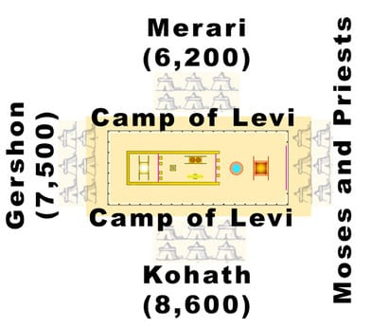
Biblical Text
³⁸ Now those who were to camp before the tabernacle eastward, before the tent of meeting toward the sunrise, are Moses and Aaron and his sons, performing the duties of the sanctuary for the obligation of the sons of Israel; but the layman coming near was to be put to death. ³⁹ All the numbered men of the Levites, whom Moses and Aaron numbered at the command of the Lord by their families, every male from a month old and upward, were 22,000.

