Leviticus 23:1-2

https://thebiblesays.com/commentary/lev/lev-23/leviticus-231-2/

God introduces His appointed times
God begins by declaring to Moses my appointed times are these. This statement makes clear that these appointed times originate with God, they cannot be claimed to have been appointed by any nation including Israel. They were appointed by the LORD.
Excluding the Sabbath, the LORD’s appointed times are typically divided into two parts:
- The spring feasts—Passover, Unleavened Bread, First Fruits, and Weeks
- The fall feasts—Feast of Trumpets, the Day of Atonement, and the Feast of Tabernacles
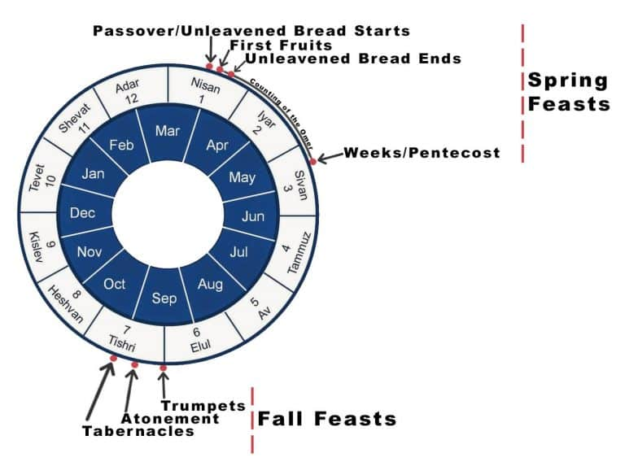
It seems clear from the New Testament that Jesus fulfilled the spring feasts in His first coming. Fulfilled prophecy that occurred in the past is easier to look back upon and see God’s plan. The fall feasts don’t appear to have been fulfilled, but will likely be fulfilled in His second coming. God places the fall feasts in the seventh month. Seven is a number signifying completeness in the Bible. This fits with the idea that the fall feasts represent the final events that will close out the current age, and usher in the new age of Jesus’ rule on earth. Future prophecy, no matter how detailed in the scripture, is difficult to see clearly. The Apostle Paul points out:
"Therefore no one is to act as your judge in regard to food or drink or in respect to a festival or a new moon or a Sabbath day, things which are a mere shadow of what is to come; but the substance belongs to Christ.” (Colossians 2:16-17)
It is important not to confuse a shadow for the object casting it. Shadows are useful as a representation of something real.
God tells Moses that it is his responsibility to proclaim to the sons of Israel these appointed times as holy convocations. The Hebrew word for convocations is “miqra” and can mean “rehearsal.” God gave His appointed times as holy rehearsals for a messianic event in the future. Jesus did and will do something of importance on each of these appointments. He died on Passover, rose from the dead on First Fruits, and sent the Holy Spirit to write the law on hearts and to dwell within believers on the Feast of Weeks (also called Pentecost). Many believe He will fulfill the Feast of Trumpets, the Day of Atonement, and the Feast of Tabernacles (also called Booths) in His second coming.
These convocations were holy. The idea of holy is to be set apart for a special purpose. These special days were to be observed, not ignored. This is likely why the chapter begins with a command to proclaim these commands to the sons of Israel.
Biblical Text
1 The LORD spoke again to Moses, saying, 2 “Speak to the sons of Israel and say to them, ‘The LORD’S appointed times which you shall proclaim as holy convocations—My appointed times are these:

