Leviticus 23:15-22

https://thebiblesays.com/commentary/lev/lev-23/leviticus-2315-22/

God declares the Feast of Weeks to be one of His appointed times. The Feast of Weeks was later named “Pentecost” by Hellenized (Greek) Jews in 300 BC.
God commands the Israelites to count for yourselves from the day after the sabbath, from the day when you brought in the sheaf of the wave offering; there shall be seven complete sabbaths (7 weeks or 49 days). This counting of days is called in tradition “the counting of the Omer.” “Omer” is Hebrew for sheaf. This counting was to begin on the feast of First Fruits when the Priest offered the sheaf of the wave offering on the first Sunday after Passover.
“You shall count seven weeks for yourself; you shall begin to count seven weeks from the time you begin to put the sickle to the standing grain.”
(Deuteronomy 16:9)
The phrase “put the sickle” means to initiate the harvest, as the sickle was used to cut the grain. To the Israelites who count these fifty days, they represent elevating oneself each day so on the Feast of Weeks they are prepared as a bride adorned with good works for her bridegroom whom she will wed at Mount Sinai. Jews today consider that they fulfilled the command You shall also count for yourselves only if they verbally counted each of the fifty days out loud. The term Pentecost was later used as a name for this feast and is Greek for the "feast of fifty".
The diagram below shows the feasts located on a circular representation of lunar months in a calendar year. The Jewish calendar was calibrated to lunar months. The inner, blue wheel shows corresponding months in the solar calendar in common use in the West.
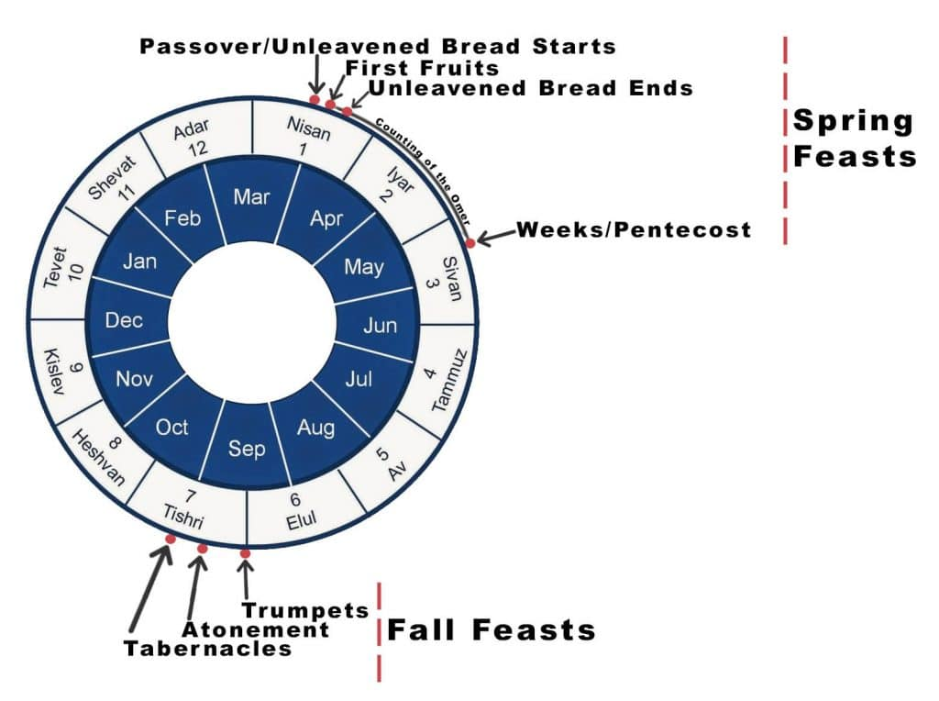
The Israelites left Egypt on the Feast of Unleavened Bread, the 15th day of the first month of the Jewish year. This was the day after Passover. Then after fifty days from leaving Egypt, Israel finds themselves at the base of Mount Sinai in Exodus 19. It is then, in the third month, that God descends on the mountain, intersecting the spiritual and the physical realms in ways that made Mount Sinai burn as if it were being incinerated in a hot furnace (Hebrews 12:18). From out of this destructive tempest came voices (Hebrew “qolot”) that some translations render as “thunderings.” Scripture says the Israelites saw or perceived the voices or thunderings on Mount Sinai (Exodus 20:18). A Jewish midrash (a midrash is a story or lesson) says on the first Pentecost they saw what was normally heard and heard what was normally seen.
The Israelites could understand one of these voices that was speaking in their language. They heard the God of the universe state His terms (the ten commandments) of the covenant, very similar to a Jewish marriage contract. The terms of this covenant also can be likened to a Suzerain-vassal treaty between the superior king (Suzerain) and his subjects (vassals, who were usually inferior kings). At the end of God speaking on the Feast of Weeks in Exodus 19 the Israelites answered in one accord “All that the LORD has spoken we will do!” thus accepting the covenant.
It seems the only time in all the wilderness encampments where the Israelites were in one accord was during the inaugural Feast of Weeks, at the base of Mount Sinai. The rest of the wilderness encampments were marked with strife and division. The unity of the Israelites at Sinai mirrors Acts chapter 2 where it says, “When the day of Pentecost had come, they were in one accord in one place.” This contrasts with just fifty days earlier (Passover), when the disciples were said to be like scattered sheep (Mark 14:27).
For the Feast of Weeks (Pentecost), each Israelite was to bring from their dwelling places two loaves of bread for a wave offering, seven one year old male lambs without defect, a bull of the herd and two rams with their grain offering and their drink offerings. During the wave offering the priest would elevate the two loaves up and down in a vertical motion, then side-to-side in a horizontal motion. It has been noted that the wave offering motions form the shape of a cross. All the Old Testament sacrifices can be paralleled to an aspect of Jesus’ sacrifice.
Usually, grain offerings are to be made without leaven. Leaven is a symbol of sin, and Jesus was without sin. However, of these two loaves it is said they are to be baked with leaven as first fruits to the LORD. Perhaps this was because this was a time of celebration, with the new harvest being gathered. The amount of fine flour to be used for the two loaves was two-tenths of an ephah. An ephah, a dry measurement, was a little over a bushel and weighed approximately 40 pounds. So, two-tenths of an ephah would have been about eight pounds of fine flour.
The male lambs are likely a foreshadowing of Jesus being sacrificed. Jesus is called “the lamb of God, that takes away the sin of the world” (John 1:29). That there are seven might picture the completeness of Jesus’ payment for our sin, since the number seven pictures completeness (Colossians 2:14).
In addition to the wave offering, a male goat for a sin offering, and two male lambs one year old for a sacrifice of peace offerings were brought. This seems like a lot to take on a pilgrimage from their dwelling places, but once settled in the land of Israel many Israelites brought money to the temple-shepherds who were trained in raising perfect sacrificial animals and purchased their sacrifices.
The temple-shepherds swaddled each lamb after birth to prevent broken bones. In fact, north of Bethlehem were located fields in which the temple-shepherds tended their sacrificial flocks in the 1st century. It was likely the temple-shepherds who raised Passover lambs to whom the angels announced the birth of the true Passover Lamb. When they visited His place of birth, they found a baby who was wrapped in swaddling clothes, just as they swaddled their lambs (Luke 2:8-12).
This offering by fire is called a soothing aroma to the LORD. The sacrifice is to be cooked on the altar such that the smoke ascends and creates the imagery that it is ascending to God, and He will be pleased by its soothing aroma.
Jesus, after His resurrection on the feast of First Fruits told His disciples to await the promise of the Father.
“And behold, I am sending forth the promise of My Father upon you; but you are to stay in the city until you are clothed with power from on high” (Luke 24:49).
The disciples stayed in Jerusalem for the whole “counting-of-the-Omer,” the fifty days until the Feast of Weeks (Pentecost) when God Himself would descend on the upper room. The upper room appears to be a parallel of Mount Sinai, an elevated place where God descended.
The Feast of Weeks is the second of the three pilgrimage feasts in which every Israelite male was to assemble at the place the Lord chose to house His presence. Acts 2:5 says Jews from every ethnicity under heaven were in Jerusalem on the Feast of Weeks and heard the voices from the upper room split up into their own languages, just as the Israelites surrounding Mount Sinai heard the voices or “thunderings” of God (Exodus 20:18).
God states that on the Feast of Weeks (Pentecost) you shall make a proclamation as well; you are to have a holy convocation. You shall do no laborious work. The Hebrew word for convocation is “miqra” which can mean “rehearsal.” God gave His appointed timesas holy rehearsals for a messianic event in the future. Holy means set apart as special. Jesus did and will do something of special importance on each of these appointments. He died on Passover, rose from the dead on First Fruits, and sent the Holy Spirit to write the law on hearts through the indwelling of the Holy Spirit on the Feast of Weeks. Pentecost is a day to do no laborious work, meaning the sabbath laws apply despite whether it falls on a normal sabbath or not. Other days like this include Passover and the last day of Unleavened Bread, the Feast of Trumpets, and the Day of Atonement, and the first and the eighth days of the Feast of Tabernacles.
God concludes His instructions for the Feast of Weeks, which honors the Spring harvest, by saying, When you reap the harvest of your land, moreover, you shall not reap to the very corners of your field nor gather the gleaning of your harvest; you are to leave them for the needy and the alien. I am the LORD your God.
Caring for the needy and the alien of the land by refraining from harvesting the corners of your field or gather the gleaning of your harvest is the kind of self-governance that pleases God. The needy could then walk through the corners of the field or the gleaning (leftovers) to gather food for their sustenance. Rather than creating a welfare system of hand outs, God wanted His people to exemplify self-governance and industry by allowing the needy and the alien the dignity of gathering for themselves. The process of gleaning means picking up the leftovers. In this manner, the field owner participated in feeding the local poor by leaving the corners of their fields unharvested and leaving some leftover gleanings for the poor to gather from the corners of the field. This generosity applied to anyone who was needy, including the alien, meaning immigrants from other nations.
The book of Ruth illustrates this principle being practiced. Ruth was an alien, being from Moab. She was also needy, being a widow and recent immigrant. She went to the field of Boaz to glean grain for her own sustenance, as well as the sustenance of her mother-in-law, Naomi (Ruth 2:3).
Biblical Text
15 ‘You shall also count for yourselves from the day after the sabbath, from the day when you brought in the sheaf of the wave offering; there shall be seven complete sabbaths. 16 You shall count fifty days to the day after the seventh sabbath; then you shall present a new grain offering to the LORD. 17 You shall bring in from your dwelling places two loaves of bread for a wave offering, made of two-tenths of an ephah; they shall be of a fine flour, baked with leaven as first fruits to the LORD. 18 Along with the bread you shall present seven one year old male lambs without defect, and a bull of the herd and two rams; they are to be a burnt offering to the LORD, with their grain offering and their drink offerings, an offering by fire of a soothing aroma to the LORD. 19 You shall also offer one male goat for a sin offering and two male lambs one year old for a sacrifice of peace offerings. 20 The priest shall then wave them with the bread of the first fruits for a wave offering with two lambs before the LORD; they are to be holy to the LORD for the priest. 21 On this same day you shall make a proclamation as well; you are to have a holy convocation. You shall do no laborious work. It is to be a perpetual statute in all your dwelling places throughout your generations. 22 ‘When you reap the harvest of your land, moreover, you shall not reap to the very corners of your field nor gather the gleaning of your harvest; you are to leave them for the needy and the alien. I am the LORD your God.’”

