Leviticus 23:23-25

https://thebiblesays.com/commentary/lev/lev-23/leviticus-2323-25/

God proclaims the fall feasts. The first of which is the Feast of Trumpets. Literally in Hebrew “The day of the shout.”
We now move from the feasts associated with the spring barley harvest and move to the festivals associated with the fall wheat harvest. God commands Moses to Speak to the sons of Israel, saying, ‘In the seventh month on the first of the month you shall have a rest, a reminder by blowing of trumpets, a holy convocation.’ The Hebrew word for convocation is “miqra” which can mean “rehearsal.” God gave His appointed times as holy rehearsals for a messianic event in the future. It is the only appointed time occurring on a first of the month. The Jewish calendar is a lunar calendar, rather than a solar calendar. Therefore, biblically, the first of the month begins with the sighting of the new moon. Thus no one knew precisely when this feast would start until the first sliver of the new moon was sighted in the western sky.
The diagram below shows the feasts located on a circular representation of lunar months in a calendar year. The Jewish calendar was calibrated to lunar months. The inner, blue wheel shows corresponding months in the solar calendar in common use in the West.
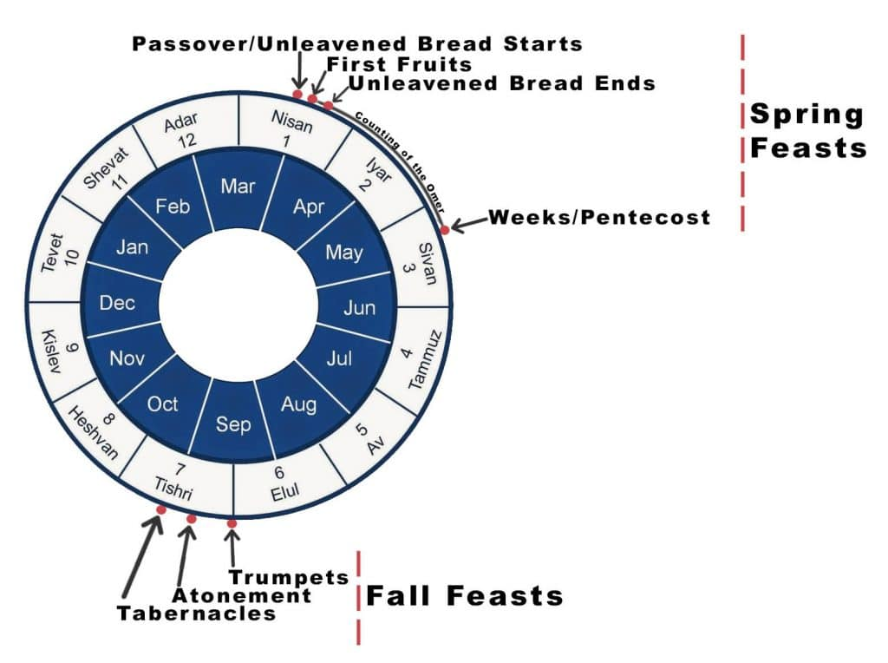
Once the moon was sighted, bonfires would be lit on the hilltops of Israel to declare a new month. Since no one could predict exactly when the Feast of Trumpets would begin it was termed by the Rabbis “The day no man knows the hour of.” In the current “diaspora” or scattering of Jews to the nations during the Roman exile, Jews observe the Feast of Trumpets for two consecutive days since the new moon could occur on either of the two. The modern name for the Feast of Trumpets is “Rosh Hashanah”, which is Hebrew for “head of the year” ever since the Babylonian exile.
Some have wondered if Jesus was alluding to this appointed time when He said His second coming would occur on a day that “no man knows the hour of” (Mark 13:32).
The phrase of trumpets is not in the Hebrew text. In Hebrew this appointment is called the day of “the shout.” Shout is “teruah” in Hebrew. In the Ancient Near East, ram’s horns or “shofars” were used to announce events to the public. The “teruah” blast from a shofar is one of several shofar signals that alert a city to an event. The teruah blast is a call to war. Many believe Paul was alluding to this appointed time when he said, “The Lord himself shall descend from heaven with a shout” (1 Thessalonians 4:16). We know from scripture that when Jesus comes back to earth, He is coming to make war against the nations who have gathered against Jerusalem (Zechariah 14 and Revelation 19:11).
Today the Hebrew calendar has two new-year holidays. A biblical one (1st of Nisan, the first month) and a civil one (1st of Tishrei, the seventh month)
Israel was commanded to have a rest on this holiday. The statement You shall not do any laborious work indicates that this is a day to which the sabbath laws apply, irrespective of whether it falls on a sabbath.
The final instruction for the Feast of Trumpets is you shall present an offering by fire to the LORD. Though not detailed here, God in Numbers 29 gives all the details of the offerings for the feasts that fall in the seventh month. The offerings for the Feast of Trumpets and the new moon on which it falls are outlined in Numbers 29:1-6.
Biblical Text
23 Again the LORD spoke to Moses, saying, 24 “Speak to the sons of Israel, saying, ‘In the seventh month on the first of the month you shall have a rest, a reminder by blowing of trumpets, a holy convocation. 25 You shall not do any laborious work, but you shall present an offering by fire to the LORD.’”

