Leviticus 23:26-32

https://thebiblesays.com/commentary/lev/lev-23/leviticus-2326-32/

God declares the Day of Atonement, (“Yom Kippur” in Hebrew) to be one of His appointed times
God tells Moses, “On exactly the tenth day of this seventh month is the day of atonement; it shall be a holy convocation for you, and you shall humble your souls.” This day is a time for Israel to humble their souls. A better translation for the word humble might be “afflict.” It has been interpreted that to humble or afflict one’s soul, one must eat no food nor drink any water for the 24 hours of the Day of Atonement. Many take it further, wearing sackcloth and abstaining from other things they enjoy. Even the high priest on the Day of Atonement had to humble himself and put off his colorful robe and the ephod, and dress like a typical priest in only the white linen garments (Leviticus 16:4). The Hebrew word for convocations is “miqra” which can mean “rehearsal.” God gave His appointed times as holy rehearsals for a messianic event in the future.
Israelites are given time for soul searching during the ten days between the Feast of Trumpets and the Day of Atonement which Jewish tradition calls “the days of awe” or “high holy days.” Then on the tenth day of this seventh month, the high priest would make offerings to make atonement on your behalf before the LORD your God. The Hebrew word for atonement is “kippur” and means “to cover” and by extension can also mean “to be reconciled.” The blood of atonement reconciled the Israelites with their Suzerain ruler Yahweh.
The diagram below shows the feasts located on a circular representation of lunar months in a calendar year. The Jewish calendar was calibrated to lunar months. The inner, blue wheel shows corresponding months in the solar calendar in common use in the West.
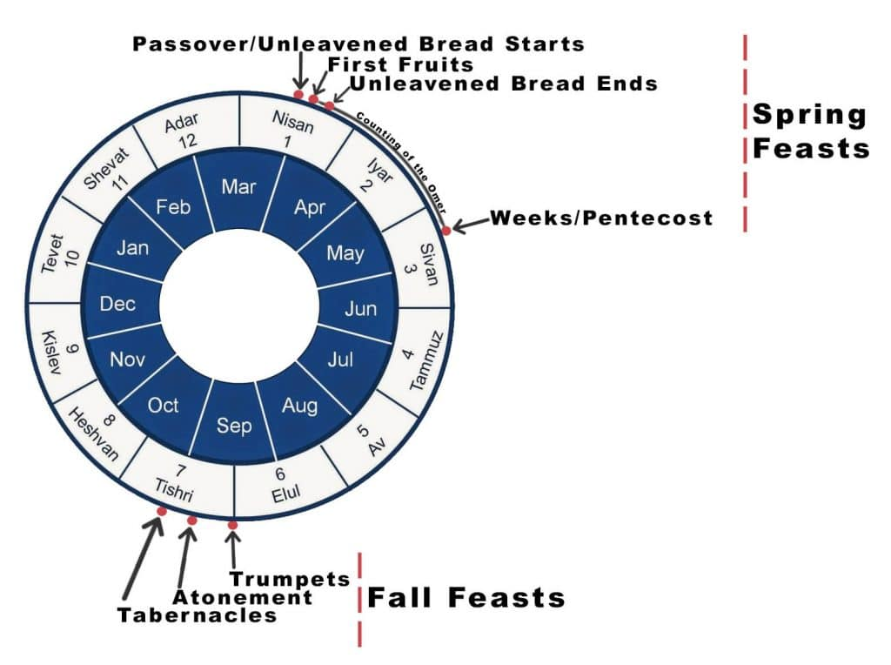
The key event for the day of atonement was when the priest presented the blood of a sacrifice upon the place of atonement interpreted as “mercy seat,” which is the cherubim on the lid of the Ark of the Covenant in the Holy of Holies.
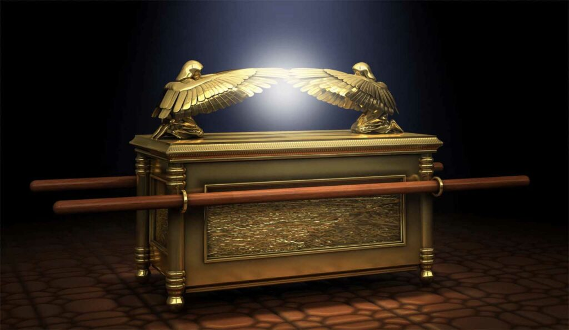
The day of atonement worship service is outlined in Leviticus 16 and is the only time a single individual (the high priest) could enter the Holy of Holies to make atonement for himself and the nation. He did this by sprinkling blood from the sacrifice onto the mercy seat. This looked forward to the sacrifice of Jesus, to open the way for humanity to enter the presence of God, through the cleansing of Jesus’ sacrifice (Hebrews 9:6-28):
“For Christ did not enter a holy place made with hands, a mere copy of the true one, but into heaven itself, now to appear in the presence of God for us” (Hebrews 9:24).
In this yearly service we learn how the High Priest is to present two goats at the tabernacle and cast two lots on them with “Yahweh” and “Azazel” inscribed on the lots. The goat which receives the “Yahweh” lot is to die as the sin offering and the other goat called “Azazel” is released into the wilderness. Jewish Tradition claims in the second Temple era a scarlet thread was tied to one of the horns of the Azazel goat and if the rite was accepted the scarlet thread would turn white. It is notable that in tractate Yoma 39b of the Talmud it says, “Our Rabbis taught: During the last forty years before the destruction of the Temple the lot (for Yahweh) did not come up in the right hand; nor did the crimson-colored strap become white.” The Jewish Temple was destroyed in 70 AD, so 40 years prior would be 30 AD, about the time of the death, burial, and resurrection of Jesus of Nazareth.
There are notable parallels between the presenting of the two goats and the account of Jesus and Barabbas in the New Testament. In the gospel accounts, the high priest convinced the crowd to choose Barabbas to be released just as the high priest would cast the lots on the Day of Atonement to determine which goat represented Yahweh and which one Azazel. This ended with Jesus dying as the sin offering and Barabbas being released.
Some Greek manuscripts of the New Testament show Barabbas’s name to be “Jesus Bar-Abbas” which is Aramaic for “Jesus, son of the father.” This fits another aspect in the presenting of the two goats. In the second temple it was mandated that the two goats be identical in stature, quality, and color so as not to tempt the high priest to cast the lots in a way that favors one goat over the other. The New Testament, being written within the framework of 1st century Judaism, addresses many things like this that were in Jewish practice during those times.
The name of the second goat “Azazel” is the name of a fallen angel mentioned in the book of Enoch, Jewish writings, as well as in Leviticus 16:26. In many Bible translations, Azazel is translated as “scapegoat.” But it is likely better left untranslated as a proper name.
Christ’s ministry is much greater than that of the Old Covenant in many ways. Christ did not just enter into the earthly tabernacle, as the high priest would have done. He actually entered the true tabernacle in heaven that God showed to Moses, in the presence of God in heaven. He did not offer the blood of animals for our sins as the Levitical high priest did, instead, he offered his own sinless blood for our sins. Lastly, he did not enter once a year as was required of the high priest, He entered once for all. By doing these greater things, Christ obtained eternal redemption for us. This redemption does not require us to perform any continual service, it is something we receive freely by simply believing (Hebrews 9:23-28).
Redemption means being released from something in exchange for a payment, like paying off a debt. Christ entered the heavenly tabernacle and paid the payment for our sins once for all, freeing us from our debt towards God. If we trust Christ’s work on the cross to save us from our sins, we receive this eternal salvation that Jesus our great high priest obtained. This is our position in Christ, our permanent entry into the family of God through a spiritual rebirth of the Spirit and acquired by faith in the promise of God in Jesus (John 3:14-16; Romans 12:5).
The statement and present an offering by fire to the LORD is referencing the other offerings for the Day of Atonement that are outlined in Leviticus 16 and Numbers 29.
God also says, You shall not do any work on this same day, for it is a day of atonement, to make atonement on your behalf before the LORD your God. The Day of Atonement is a day of rest meaning that all the laws that apply to the sabbath day apply to it with a particularly strict punishment stated for that person who will not humble himself on this same day. That he shall be cut off from his people. To be cut off means to no longer have a place in Israel, a punishment that could be administered through death (Number 4:17-19; Genesis 9:11). Moses also instructed that As for any person who does any work on this same day, that person I will destroy from among his people. In addition to commanding Israel to administer justice to those who broke the rest on the Day of Atonement, Moses added that God would destroy from among his people those who refused to humble themselves on this holy day.
God declares to Israel that the Day of Atonement is a perpetual statute and should be observed throughout your generations in all your dwelling places. God intended for this ceremony to continue on throughout the generations. This was to continue in all their dwelling places, although the sacrifices can only be offered when the Jewish Temple is in operation.
Biblical days are reckoned from evening until the next evening, as shown in verse 32, from evening until evening you shall keep your sabbath.
Biblical Text
26 The LORD spoke to Moses, saying, 27 “On exactly the tenth day of this seventh month is the day of atonement; it shall be a holy convocation for you, and you shall humble your souls and present an offering by fire to the LORD. 28 You shall not do any work on this same day, for it is a day of atonement, to make atonement on your behalf before the LORD your God. 29 If there is any person who will not humble himself on this same day, he shall be cut off from his people. 30 As for any person who does any work on this same day, he shall be cut off from his people. 30 As for any person who does any work on this same day, that person I will destroy from among his people. 31 You shall do no work at all. It is to be a perpetual statute throughout your generations in all your dwelling places. 32 It is to be a sabbath of complete rest to you, and you shall humble your souls; on the ninth of the month at evening, from evening until evening you shall keep your sabbath.”

