Leviticus 23:33-44

https://thebiblesays.com/commentary/lev/lev-23/leviticus-2333-44/

God declares the Feast of Tabernacles to be one of His appointed times.
God outlines His final yearly appointed time called Tabernacles (“sukkot” in Hebrew) translated here as booths. The Feast of Booths occurs on the fifteenth of the seventh month, just five days after the solemn Day of Atonement, and lasts seven days with an additional eighth day mentioned.
The diagram below shows the feasts located on a circular representation of lunar months in a calendar year. The Jewish calendar was calibrated to lunar months. The inner, blue wheel shows corresponding months in the solar calendar in common use in the West.
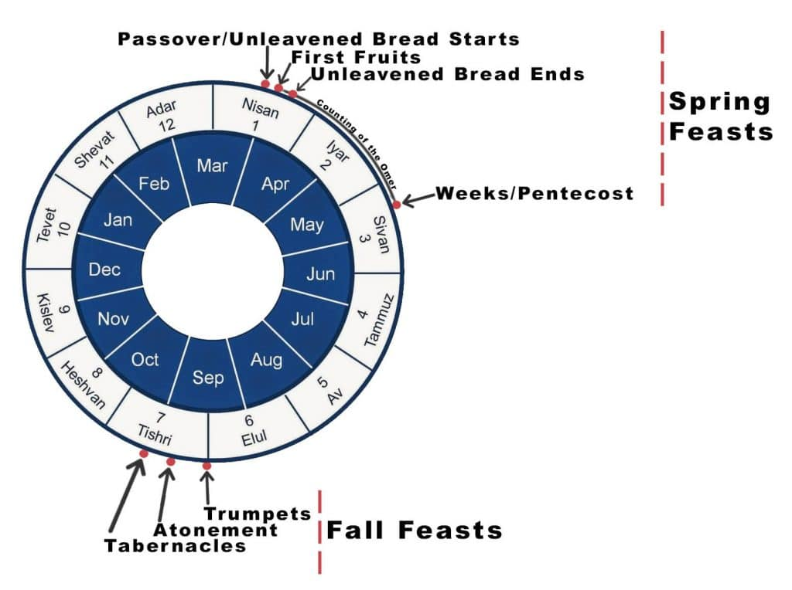
Just five days after confessing sins and afflicting oneself during the Day of Atonement, God says, you shall rejoice before the LORD your God for seven days. God’s atonement and forgiveness of sins on the Day of Atonement was now something to rejoice about, being reconciled to their King. Throughout that year each person had allowed that year’s sins to separate them from fellowship with their King. Now that the Day of Atonement is past, innocent blood has been shed, and reconciliation has been made, each person would rejoice in God’s presence for seven days. The time of rejoicing, living together in harmony, could picture the Kingdom of God on earth that will be set up after Jesus returns to earth a second time (Revelation 19:6).
The first day and the eighth day of this appointed time are to be sabbaths of rest with God proclaiming, You shall do no laborious work. The eighth day is called in Hebrew “Shemini Atzeret” and is looked at in Jewish tradition as its own distinct appointed time. It is specifically mentioned in Nehemiah 8:
“He read from the book of the law of God daily, from the first day to the last day. And they celebrated the feast seven days, and on the eighth day there was a solemn assembly according to the ordinance.”
(Nehemiah 8:18)
The Eighth Day is called “The last day, the great day of the feast” in John 7:37.
The Israelites are commanded seven days you shall present an offering by fire to the LORD.
The specifics of the offerings by fire for the Feast of Booths are outlined in Numbers 29:12-38.
God repeats that, these are the appointed times of the LORD which you shall proclaim as holy convocations. Like the other festivals, these are convocations, or gatherings of the people, to assemble together. It was to be a time of fellowship and celebration, to present offerings by fire to the LORD—burnt offerings and grain offerings, sacrifices and drink offerings, each day’s matter on its own day. Part of these offerings would be burnt, and part kept by the Levites. But most of the offerings would provide a barbecue dinner for the celebrants. They would offer sacrifices to the LORD then really enjoy themselves in fellowship. This pictures the two great commandments. First, God is honored. Then, the way God wants us to honor Him is to love one another. One way to do that is to enjoy fellowship with one another. This was all to be done besides those of the sabbaths of the LORD, and besides your gifts and besides all your votive and freewill offerings, which you give to the LORD. The offerings of the Feast of Tabernacles (Booths) was to be in addition to the routine sabbaths and offerings.
God is careful to insist on complete observance to His appointed times. This could be considered watching and waiting. Watching by observing all He commands and waiting by hoping for the fulfillment of His appointed times, as will be fulfilled in the second coming of Christ. The Apostle Paul speaks of this messianic fulfillment in the following manner:
“Therefore no one is to act as your judge in regard to food or drink or in respect to a festival or a new moon or a Sabbath day, things which are a mere shadow of what is to come; but the substance belongs to Christ.”
(Colossians 2:16-17)
It is important not to confuse a shadow for the object casting it. Shadows are useful as a representation of something real.
The Israelites were to build tabernacles or booths (“sukkot” in Hebrew) to live in during these seven days. These would be temporary shelters, to remind them of their time wandering in the wilderness, when they all lived in tents. It also reminds us of God’s deliverance of the nation from Egypt, through their wanderings. It is Jewish tradition that if a person eats dinner in the booth each of the seven evenings, they are considered to have fulfilled the commandment to live in booths for seven days. There is also a command that all the native-born in Israel shall live in booths.
We see in Genesis 33:17 that booths were used as animal cribs:
“Jacob journeyed to Sukkot (booths) and built for himself a house and made booths (sukkot) for his livestock; therefore, the place is named Sukkot.”
The New Testament says Jesus was born in a manger. The Greek word in the New Testament for manger is “phatnē” which means “a crib for animals.” It could be that Jesus was born during the Feast of Booths.
In the future during the millennial kingdom we are told that even the gentile nations will be required to make pilgrimage to Jerusalem on the Feast of Booths.
“Then it will come about that any who are left of all the nations that went against Jerusalem will go up from year to year to worship the King, the LORD of hosts, and to celebrate the Feast of Booths” (Zechariah 14:16).
God lastly specifies four species of plants for the Israelites to gather on the Feast of Tabernacles, Now on the first day you shall take for yourselves:
- the foliage of beautiful trees,
- palm branches and
- boughs of leafy trees and
- willows of the brook,
The Israelites are to take these four species of vegetation and you shall rejoice before the LORD your God for seven days.
Jews today bind these four species of plants together into what is called a “Lulav and Etrog.” There is much symbolism that has been discussed regarding the four species, but the most recurring theme is that each of the four species represents a letter of God’s divine name spelled in transliterated Hebrew “YHWH.” When the four species are bound as one it represents the unification of God’s name, something Jews pray for three times a day.
Although Jesus’ triumphant entry into Jerusalem occurs just prior to Passover, it has imagery of the Feast of Booths with the crowds waving palm branches and rejoicing welcoming their King into Jerusalem. Jesus will enter Jerusalem triumphantly a second time. But instead of leading Jesus to His death, this second triumphant entry will culminate with Jesus taking His rightful place as King of the earth (Zechariah 14:9).
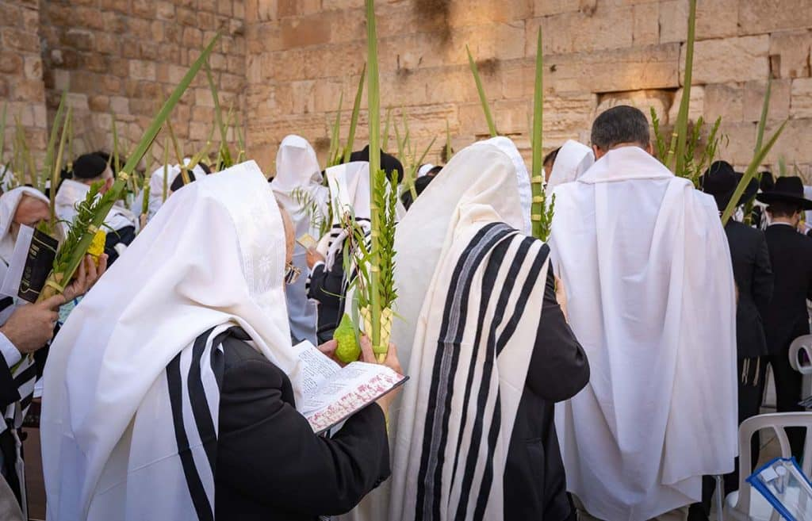

Western Wall during the Feast of Tabernacles
This section ends with God telling Israel one of the primary purposes for the Feast of Tabernacles, or Booths. Here God says, I had the sons of Israel (His Flock) live in booths when I brought them out from the land of Egypt. I am the LORD your God.” Israel lived in temporary shelters while wandering in the wilderness. They dwelt in tents. Once they entered the Promised land, they dwelt in great, permanent dwellings. The LORD warned Israel to remember their roots, saying in Deuteronomy:
“Then it shall come about when the Lord your God brings you into the land which He swore to your fathers, Abraham, Isaac and Jacob, to give you, great and splendid cities which you did not build, and houses full of all good things which you did not fill, and hewn cisterns which you did not dig, vineyards and olive trees which you did not plant, and you eat and are satisfied, then watch yourself, that you do not forget the Lord who brought you from the land of Egypt, out of the house of slavery.”
(Deuteronomy 6:10-12)
It seems the Feast of Booths was intended to help Israel with this command, to remember where they came from. They dwelt in tents in the wilderness, after coming out of slavery in Egypt. It was important that they not forget how blessed they were.
Finally it is said Moses declared to the sons of Israel the appointed times of the LORD. This was God’s blessing to Israel, to help them remember, and retain a proper perspective.

Biblical Text
33 Again the LORD spoke to Moses, saying, 34 “Speak to the sons of Israel, saying, ‘On the fifteenth of this seventh month is the Feast of Booths for seven days to the LORD. 35 On the first day is a holy convocation; you shall do no laborious work of any kind. 36 For seven days you shall present an offering by fire to the LORD. On the eighth day you shall have a holy convocation and present an offering by fire to the LORD; it is an assembly. You shall do no laborious work.
37 ‘These are the appointed times of the LORD which you shall proclaim as holy convocations, to present offerings by fire to the LORD—burnt offerings and grain offerings, sacrifices and drink offerings, each day’s matter on its own day— 38 besides those of the sabbaths of the LORD, and besides your gifts and besides all your votive and freewill offerings, which you give to the LORD.
39 ‘On exactly the fifteenth day of the seventh month, when you have gathered in the crops of the land, you shall celebrate the feast of the LORD for seven days, with a rest on the first day and a rest on the eighth day. 40 Now on the first day you shall take for yourselves the foliage of beautiful trees, palm branches and boughs of leafy trees and willows of the brook, and you shall rejoice before the LORD your God for seven days. 41 You shall thus celebrate it as a feast to the LORD for seven days in the year. It shall be a perpetual statute throughout your generations; you shall celebrate it in the seventh month. 42 You shall live in booths for seven days; all the native-born in Israel shall live in booths, 43 so that your generations may know that I had the sons of Israel live in booths when I brought them out from the land of Egypt. I am the LORD your God.’” 44 So Moses declared to the sons of Israel the appointed times of the LORD.

