Leviticus 23:4-8

https://thebiblesays.com/commentary/lev/lev-23/leviticus-234-8/

God declares the 14th day of the first month to be Passover. Passover starts a 7-day feast called Unleavened Bread; most see them as one feast.
The statement, ‘These are the appointed times of the LORD, holy convocations which you shall proclaim at the times appointed for them” in verse 4 is virtually a restatement of verse 2. This statement separates the sabbath’s weekly appointed time from the yearly appointed times about to be given. This also may signify a greater importance to the sabbath day. The Hebrew word for convocations is “miqra” which can mean “rehearsal.” God gave His appointed times as holy rehearsals for a messianic event in the future. Beyond the weekly and yearly appointed times given in this chapter, later in Leviticus we will see the appointed time called Jubilee which occurs every 50 years. We will also see the sabbatical seventh year in which the land has an appointment to rest.
Each of the appointed times occur at a particular time in the year. And the appointed times had holy convocations attached. The convocations were gatherings of the nation to worship and celebrate. They were holy, meaning they were set apart as something special. A day that was to be observed, not ignored. In general, the holy convocations included a lot of fellowship that likely would have been highly enjoyable, and served as an incentive to encourage participation.
God begins by declaring, In the first month, on the fourteenth day of the month at twilight is the LORD’S Passover. It was on this day and time the Israelites had slaughtered their lambs and painted the blood on their doorposts in Egypt, the night of the first Passover. It was this event that pushed Pharaoh to release them from slavery. The holiday is called Passover because the Death Angel “passed over” every door that was marked with blood (Exodus 12:27-30).
The wording at twilight can be a little confusing. The Hebrew literally says, “between the evenings.” Exodus 12 gives several additional details as to the observances of Passover and the same phrase at twilight is used to describe the time to slay the Passover lambs in Exodus 12:6. For centuries, Jewish tradition has understood the phrase “between the evenings” to mean only lambs offered from the sixth hour (12pm) to the eleventh hour (5pm) were accepted on Passover. Matthew indicates that Jesus was crucified and hung on the cross from the sixth hour to the ninth hour (Matthew 27:45).
In Numbers 9:10-11 we see how important it was to God that all of the sons of Israel kept Passover. In Numbers 9, there were men defiled by touching a dead body, so they could not keep the Passover in the first month, on the fourteenth day of the month as prescribed. God then told Moses to institute the fourteenth day of the second month as a second Passover for those who cannot keep it in the first month because of being ritually unclean.
Passover begins a seven-day appointed time, or holiday called Unleavened Bread which starts on the day after Passover, the fifteenth day of the same month. During this seven-day appointed time, Israelites are commanded for seven days you shall eat unleavened bread. In Exodus 12:15 Israelites are commanded to search their homes prior to the feast of unleavened bread for any traces of leaven and remove it. This is a picture of removing sin out of our life. Today when Jews purge the leaven from their homes, even after making their best effort they realize that there are still many crumbs hidden behind the refrigerator or on shelves. They call on God to count the remaining unseen leaven as purged seeing it’s impossible for them to remove all the leaven on their own.
The apostle Paul encourages believers to diligently do the same with sin:
“Clean out the old leaven so that you may be a new lump, just as you are in fact unleavened. For Christ our Passover also has been sacrificed. Therefore, let us celebrate the feast, not with old leaven, nor with the leaven of malice and wickedness, but with the unleavened bread of sincerity and truth.”
(1 Corinthians 5:7-8)
Unleavened Bread is called “matzah” in Hebrew and must be made according to tradition “pierced and striped” in order to prevent it from being puffed up with leaven. This looks forward to Christ, as Jesus was pierced and striped, as predicted by Isaiah:
“But He was pierced through for our transgressions,
He was crushed for our iniquities;
The chastening for our well-being fell upon Him,
And by His scourging we are healed.”
(Isaiah 53:5)
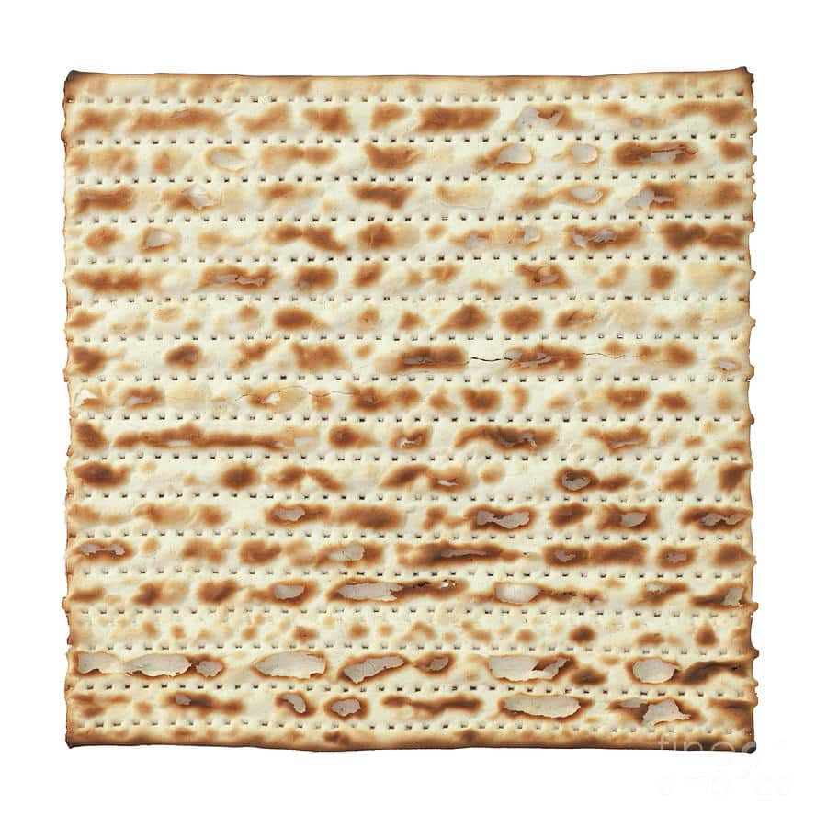
Passover is the first of three pilgrimage feasts in which the sons of Israel were required to go to the place of the tabernacle (or later the Temple in Jerusalem) to make a sacrifice and to fellowship with God and fellow Israelites.
God insists that during the seven days of unleavened bread the Israelites must present an offering by fire to the LORD. The phrase by fire indicates that these are to be burnt offerings (literally “offerings of ascent”) These offerings by fire are outlined in Numbers 28:19-24.
The statement on the seventh day is a holy convocation; you shall not do any laborious work means not only was Passover to be a day of rest, but the last day of Unleavened Bread was also a day to which the sabbath laws apply, whether or not it fell on a normal sabbath. Other days like this include the Feast of Weeks, the first and the eighth days of the Feast of Tabernacles, the Feast of Trumpets, and the Day of Atonement. The Hebrew word for convocations is “miqra” which can mean “rehearsal.” God gave His appointed times as holy rehearsals for a messianic event in the future.
The Feast of First Fruits outlined next in verses 9-14, occurs within the Feast of Unleavened Bread being the first Sunday after Passover.
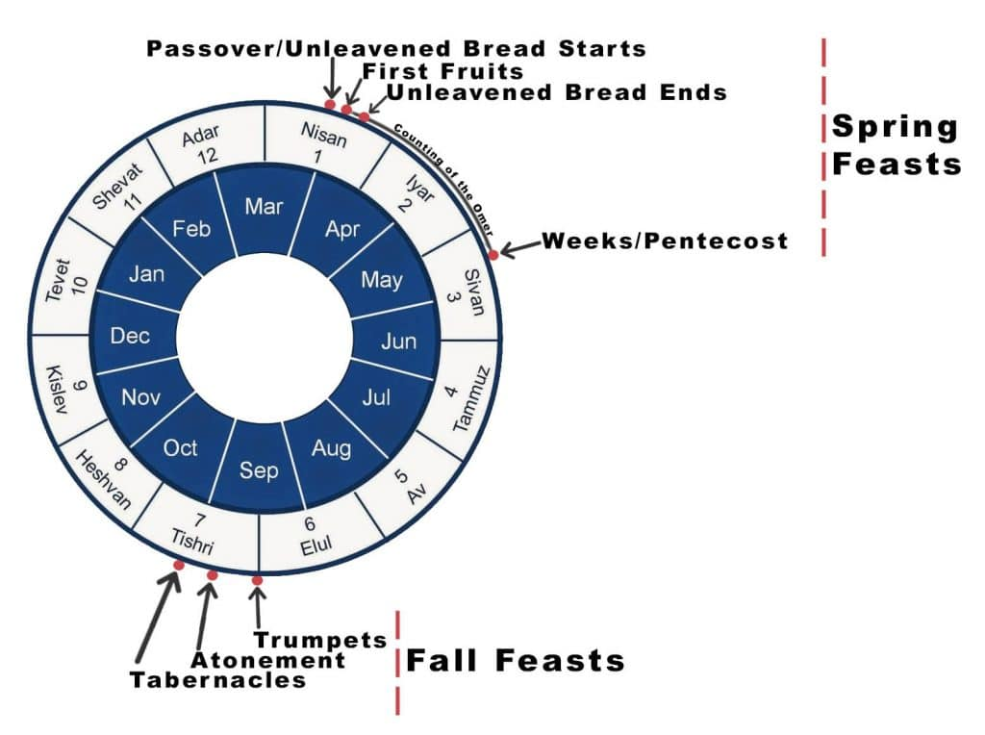
Jesus, at His last Passover meal with His disciples, said, “Do this in remembrance of me” (Luke 22:19). The disciples must have been astonished because for 1500 years the Israelites had been taught to eat the Passover meal and perform its service in remembrance of the exodus from Egypt. At His last supper, Jesus shows how Passover was ultimately pointing towards His sacrifice on the cross by asking His disciples to, from that point forward, keep the feast in remembrance of Him. Jesus’ crucifixion was the real event casting the “shadow” or illustration of Passover. Christian communion comes from this tradition and is usually kept with unleavened bread and wine.
To read more about the different aspects of Passover please refer to our following articles:
- The Original Passover
- Jesus and the Messianic Fulfillments of Passover and Unleavened Bread
- The Passover Seder
- Jesus’s Last Supper as a Passover Seder
Biblical Text
4 ‘These are the appointed times of the LORD, holy convocations which you shall proclaim at the times appointed for them. 5 In the first month, on the fourteenth day of the month at twilight is the LORD’S Passover. 6 Then on the fifteenth day of the same month there is the Feast of Unleavened Bread to the LORD; for seven days you shall eat unleavened bread. 7 On the first day you shall have a holy convocation; you shall not do any laborious work. 8 But for seven days you shall present an offering by fire to the LORD. On the seventh day is a holy convocation; you shall not do any laborious work.’”

